PROJECT REPORT
CRYPTOGRAPHY
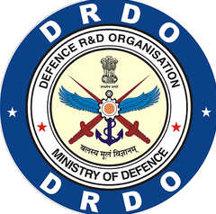
Integrated Test Range
Defence Research and Development Organization
Chandipur – 756025

Under the Guidance of
Dr Arun Kumar Ray
(Scientist-G, Group Director, EOTS)

Under the Supervision of
Dr Ganesh Ramani
(EOTS)

Submitted By
Rohan Mahapatra
Electronics And Telecommunication Engineering, VSSUT
Regd no. - 2202070091

Certificate

This is to certify that the work contained in the report “Cryptography” is a bonafide record of work carried out by Rohan Mahapatra. This project was undertaken during the internship at EOT division, ITR, DRDO from [2/06/2025] to [1/07/2025] and this work has not been submitted elsewhere for a degree.

Dr Arun Kumar Ray Dr Ganesh Ramani
(Scientist-G, Group Director, EOTS) (Scientist- , EOTS)

Ackowledgemnt

We owe our sincere gratitude to all those who have been a source of encouragement and support throughout this project. We are extremely grateful to Dr Arun Kumar Ray, Scientist-G, GD, EOT division Integrated Test Range for having suggested the topic of our project and for his persistent guidance and direction.

We are indebted to Mr. Ganesh Ramani, Scientist-, ITR for their constant help and motivation right from the beginning of this project until this stage. Their valuable suggestions are the most important input which has assisted in all respects. We are immensely grateful to our parents, whose support has led us to successfully utilize this opportunity.

Contents

ABOUT DRDO
DRDO is the R&D wing of Ministry of Defence, Govt of India, with a vision to empower India with cutting-edge defence technologies and a mission to achieve self-reliance in critical defence technologies and systems, while equipping our armed forces with state-of-the-art weapon systems and equipment in accordance with requirements laid down by the three Services. DRDO's pursuit of self-reliance and successful indigenous development and production of strategic systems and platforms such as Agni and Prithvi series of missiles; light combat aircraft, Tejas; multi-barrel rocket launcher, Pinaka; air defence system, Akash; a wide range of radars and electronic warfare systems; etc., have given quantum jump to India's military might, generating effective deterrence and providing crucial leverage.

"Balasya Mulam Vigyanam"—the source of strength is science-drives the nation in peace and war. DRDO has firm determination to make the nation strong and self-reliant in terms of science and technology, especially in the field of military technologies. DRDO was formed in 1958 from the amalgamation of the then already functioning Technical Development Establishment (TDEs) of the Indian Army and the Directorate of Technical Development & Production (DTDP) with the Defence Science Organisation (DSO). DRDO was then a small organization with 10 establishments or laboratories. Over the years, it has grown multi-directionally in terms of the variety of subject disciplines, number of laboratories, achievements and stature.

Today, DRDO is a network of around 41 laboratories and 05 DRDO Young Scientist Laboratories (DYSLs) which are deeply engaged in developing defence technologies covering various disciplines, like aeronautics, armaments, electronics, combat vehicles, engineering systems, instrumentation, missiles, advanced computing and simulation, special materials, naval systems, life sciences, training, information systems and agriculture. Several major projects for the development of missiles, armaments, light combat aircrafts, radars, electronic warfare systems etc. are on hand and significant achievements have already been made in several such
technologies.

ITR

Integrated Test Range (ITR), a well-equipped Test and Evaluation (T&E) center of DRDO, is set up to provide safe and reliable launch facilities for performance evaluation of rockets, missiles and air-borne weapon system. One of the most essential and important parts of the design evaluation of various flight vehicles is to precisely locate the flying objects from take-off to the point of impact through entire trajectory along with measurement of various health parameters. Various high performance Range Instrumentation Systems such as Electro Optical Tracking System (EOTS), Radar System, Telemetry System and Central Computer System are deployed and configured in real time to provide necessary data (precise location and health parameters) of airborne targets through entire course of flight. ISO 9001:2015 quality system implementation at ITR has given adequate confidence to the Projects/Users/Customers in terms of quality and reliability of overall Range performance. In order to support various types of missions, a number of well-established test procedures and simulations are conducted so as to keep the Range always in a state of readiness. All the above state-of-the-art Range instruments, support facilities along with the test procedures have enabled the Range to provide vital data to the Projects/Users/Customers over the years…

ITR is Equipped with high-performance range instrumentation systems like EOTS, Radar, and Telemetry systems to track and capture data during flight

Introduction
Electro-Optical Targeting System (EOTS)
The Electro-Optical Targeting System (EOTS) is an advanced, multi-functional sensor suite used primarily in modern combat aircraft for precision targeting, surveillance, and tracking. It combines several capabilities—such as infrared imaging, laser designation, and tracking sensors—into a single, integrated and stealth-optimized system.
EOTS represents a significant leap in electro-optical targeting technology, enabling pilots to detect, identify, and engage threats from long distances, under all weather and lighting conditions, and without alerting adversaries.

Purpose and Role in Modern Warfare
Modern aerial combat and strike missions demand precision, stealth, and real-time situational awareness. The EOTS fulfills these requirements by serving three main roles:
- Surveillance & Reconnaissance: Provides real-time intelligence through high-resolution infrared imaging.
- Target Acquisition & Tracking: Locates and continuously tracks both ground and airborne targets.
- Target Designation & Engagement: Uses a laser to guide precision munitions (e.g., laser-guided bombs and missiles) to the selected target.

Components crucial to EOTS
Component | Function
FLIR (Forward-Looking Infrared) | Thermal imaging for night vision and target identification.
IRST (Infrared Search and Track) | Passive detection of heat-emitting targets (like aircraft) at long range.
Laser Rangefinder/Designator | Measures distance and guides laser-guided weapons with pinpoint accuracy.
Optical Sensors | Provide high-definition visual imagery and magnification of targets.
Image Processing Software | Assists in real-time object recognition, stabilization, and threat analysis.

CRYPTOGRAPHY
What is Cryptography?
Cryptography is the science of securing information by transforming it into a form that unauthorized users cannot understand. It enables secure communication in the presence of malicious third parties, commonly known as adversaries.
Derived from the Greek words kryptos (hidden) and graphein (to write), cryptography essentially means “hidden writing.”
Cryptography, though vital to modern electronic communication, has ancient origins. The earliest known use dates back to around 2000 B.C. in Egypt, where non-standard hieroglyphics were used to conceal messages. Since then, many civilizations with written language have employed some form of secret writing. Notable historical examples include the scytale cipher used in ancient Sparta and the Caesar cipher developed in ancient Rome—both early methods of protecting sensitive information.

While Cryptography is the science of secret writing aimed at concealing the meaning of a message, Cryptanalysis is the science — and often the art — of breaking cryptographic systems and uncovering hidden information.

Asymmetric Cryptography
Definition
Asymmetric cryptography, also known as public-key cryptography, uses a pair of keys — a public key and a private key — to encrypt and decrypt data. The public key is shared openly and used for encryption, while the private key is kept secret and used for decryption. This eliminates the need to share a single secret key and significantly enhances security, especially for digital communications over open networks. Asymmetric cryptography is widely used in secure email, digital signatures, and online transactions. Common algorithms include RSA (Rivest–Shamir–Adleman) and Elliptic Curve Cryptography (ECC).

It is widely used in:
- 🔐 Secure communication
- 📝 Digital signatures
- 🌐 SSL/TLS for secure websites
- 📱 End-to-end encryption in messaging apps
- 🧾 Verifying documents and software updates

Here’s An Example of Alice and Bob using Asymmetric Cryptography
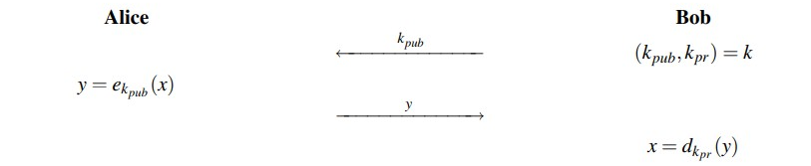
Bob generates a key pair:
- Public key (kₚᵤb) – shared with everyone
- Private key (kₚᵣ) – kept secret
Alice wants to send a secret message to Bob:
- She encrypts the message using Bob’s public key (kₚᵤb)
Bob receives the encrypted message:
- He decrypts it using his private key (kₚᵣ)

RSA
In 1977, Ronald Rivest, Adi Shamir and Leonard Adleman proposed a scheme which became the most widely used asymmetric cryptographic scheme called RSA. RSA is a public-key cryptosystem that is used for secure data transmission, especially in applications like secure emails, digital signatures, and online transactions. It is based on the mathematical difficulty of factoring large prime numbers — a problem that is easy to verify but extremely hard to reverse.
RSA uses two keys:
- A public key for encryption (shared openly)
- A private key for decryption (kept secret)
Anyone can use the public key to encrypt data, but only the holder of the private key can decrypt it. Before the application of RSA, some prerequisite knowledge on Fermat’s(little) Theorem and Euler’s Theorem are required.

Fermat’s (little) Theorem
Fermat’s Little Theorem is a fundamental result in number theory. It states:
If p is a prime number and a is an integer such that a is not divisible by p, then:
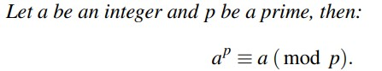
Fermat’s Little Theorem is fundamental to public-key cryptography, particularly:
- RSA algorithm (used in modular arithmetic and modular inverses)
- Fast modular exponentiation
- Finding large prime numbers
- Modular inverse calculation (e.g., computing private keys)
Modulo Multiplicative Inverse
The modulo multiplicative inverse of an integer a modulo n is an integer x such that:
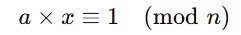

Euler’s Theorem
Euler’s Theorem is a generalization of Fermat’s Little Theorem. It states:
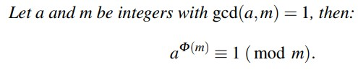
Where:
- φ(n) is Euler’s totient function, which counts the number of integers less than n that are coprime to n.
It is used in RSA to compute the modular inverse of the public exponent e, which helps generate the private key d:
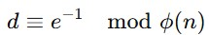
Relationship with Fermat’s Theorem
Fermat's Little Theorem is a special case of Euler’s Theorem when n is a prime number:
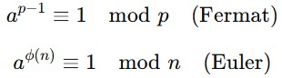

ALGORITHM
1. Key Generation
The process of creating a matching pair of public and private keys for secure communication.
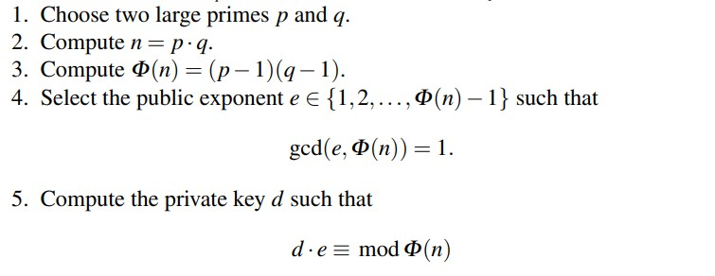
🔓 Public Key: (e,n) – shared with everyone
🔒 Private Key: (d,n) – kept secret

2. Encryption
The process of converting a plaintext message into an unreadable ciphertext using the recipient's public key.
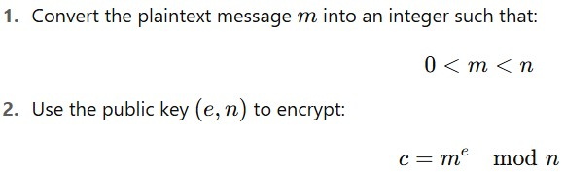
Where:
c is the ciphertext

3. Decryption
The process of converting the ciphertext back into the original plaintext using the private key.
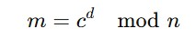
Where:
c = the encrypted message (ciphertext)
d = private exponent
n = modulus
m = original plaintext message

Code
1. Key Generation
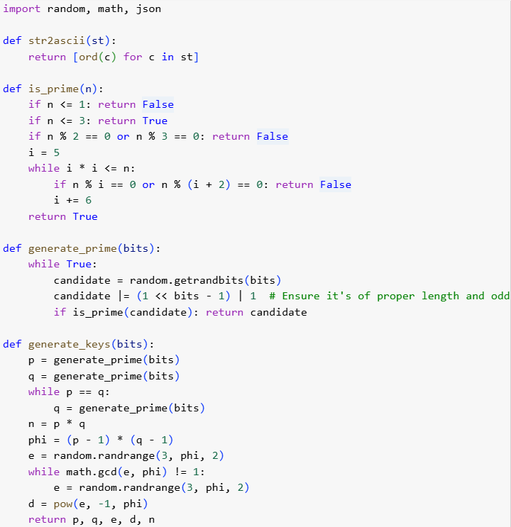

2. Encryption
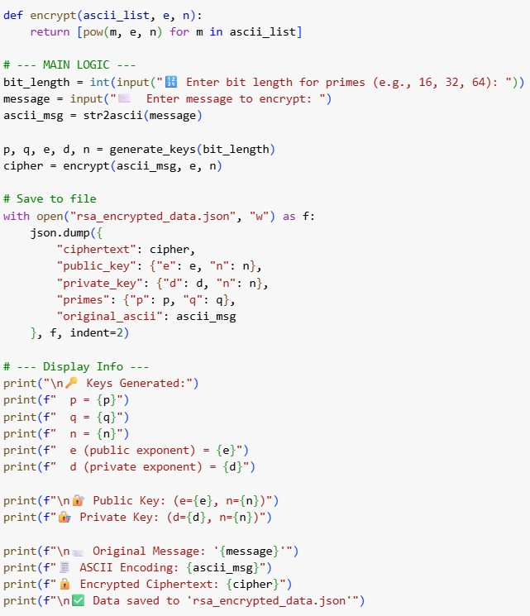
Output
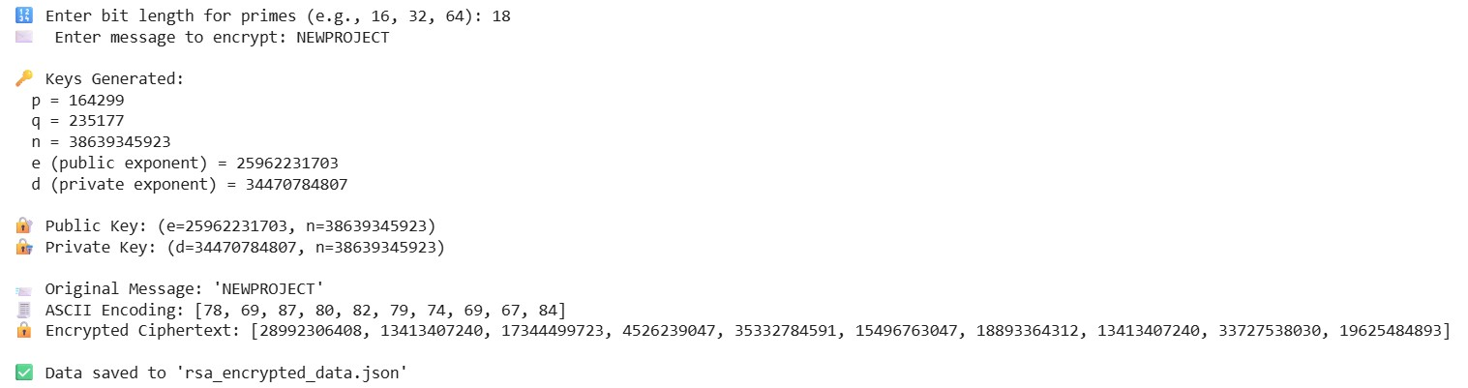

3. Decryption
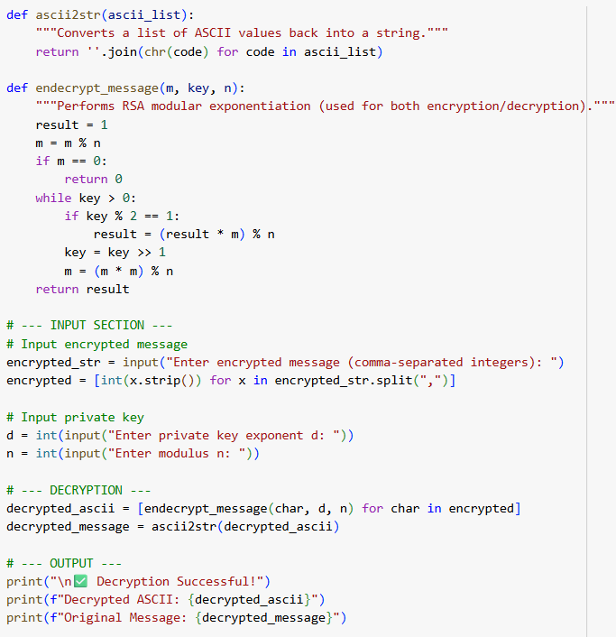

OUTPUT

Comparison between Symmetric and Asymetric
Symmetric cryptography is a method where the same key is used for both encryption and decryption. This means that both the sender and the receiver must have access to the same secret key, which creates a major challenge: secure key distribution. If this key is intercepted or leaked, the entire communication becomes compromised. However, symmetric encryption is highly efficient and fast, making it ideal for encrypting large amounts of data, such as files or databases. Popular symmetric algorithms include AES, DES, and Blowfish.
On the other hand, asymmetric cryptography uses two mathematically related keys — a public key for encryption and a private key for decryption. The public key can be shared freely, while the private key is kept secret by the receiver. This approach solves the key distribution problem because there's no need to share the private key. Asymmetric encryption provides enhanced security and is widely used in digital signatures, secure email, and SSL/TLS protocols. However, it is slower and computationally heavier than symmetric encryption, which is why it’s typically used to encrypt only small amounts of data (e.g., symmetric keys or authentication tokens). Common algorithms include RSA, Elliptic Curve Cryptography (ECC), and DSA.

Conclusion
Cryptography plays a vital role in ensuring the confidentiality, integrity, and authenticity of information in the digital age. From securing personal communications to protecting financial transactions and sensitive government data, cryptography forms the foundation of trust in cyberspace.
Both symmetric and asymmetric cryptography serve essential purposes. Symmetric cryptography, with its speed and efficiency, is ideal for encrypting large amounts of data. However, it faces challenges in secure key distribution. On the other hand, asymmetric cryptography offers a solution to key exchange problems by using public and private key pairs, but is computationally heavier.
In modern systems, both methods are often used together in a hybrid approach. For example, in secure web communications (like HTTPS), asymmetric encryption is used to exchange a symmetric session key, and then symmetric encryption takes over to handle the data transfer efficiently. This combination leverages the strengths of both techniques, ensuring both security and performance.
As technology advances, especially with the rise of quantum computing and interconnected devices, cryptography will continue to evolve — but its core purpose remains the same: to protect information in a world that increasingly depends on it.

Reference
Understanding Cryptography (Christof Paar, Jan Pelzl)
GeeksForGeeks

